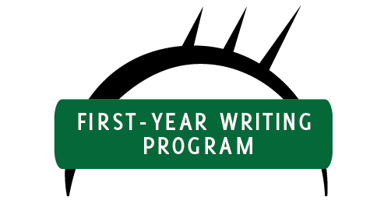

The First-year Writing Program's curriculum maps are stored in Google Drive as dynamic documents in an effort to both make changes collaboratively and to prevent outdated versions from circulating. Please find the curriculum maps in the FYWP's shared folder at https://drive.google.com/folderview?id=0B5WcEW_udpHVYnc3UlZWb054T1E&usp=sharing.

