Segmented Transitioning: A Cross-unit Segue

Introduction (Genre to Rogers):
The following collection of activities is meant to help segue between Unit 2 and Unit 3 of ENGL/WRTG 120. The collection is meant to enhance student retention of genre theory and textual analysis, while also introducing concepts that may be fundamental for a group’s successful application of Rogerian argument.

Overview:
Distribute images of art works of your choice to students as you see fit. I gave groups of four students an image of a work by Banksy and prompted them to write. I did this on two different occasions, each time with a different image. I gave them ten minutes each time.

Pertinent Texts Studied Prior:
Print:
Understanding Rhetoric:
“Introduction”
“Issue 1”
“Issue 2”
Dirk’s “Navigating Gernes”
Malcolm X’s “Learning to Read”
Alexie’s “Superman and Me”
a section from Art Spiegelman’s Maus,
John Wu’s “A Generic College Paper,”
Video:
The Glossary’s David Foster Wallace “This is Water,”
“Demonstrators 'disrupt' STL symphony singing a 'Requiem for Mike Brown'”

We had also read and critiqued each other’s drafts twice. For the class following the end of this string of assignments we read “Issue 3: Writing Identities,” of Understanding Rhetoric.

On My Choice of Images:
While a variety of art could work for this assignment, I found that using street art specifically challenged and intrigued students and focused their attention on current historical and political situations.

Layout:
Administer prompts #1 and #2 during the two final class periods of Unit 2, one per class period. Administer prompt #3a, the handout, and Prompt #3b during the first class period of Unit 3. The Diagram is to be drawn on the board at some point before you administer the handout.

Prompt(s) #1 (& 2):
Write about a possible rhetorical context for these images. Consider: author (exigence, application of Aristotelian concepts), text (genre, physical location), and audience (expectations, ideal readers, etc.)

Prompt #3-a:
If you were an audience member for one of Banksy’s art works, how would you react? Write a detailed response of your possible reaction. Make sure to include the rhetorical context—the actual physical space in which these art works occur—in your description.

Handout:
Intersectionality is a term that was coined by American professor Kimberlé Crenshaw in 1989. The concept already existed but she put a name to it. The textbook definition states: “The view that women experience oppression in varying configurations and in varying degrees of intensity. Cultural patterns of oppression are not only interrelated, but are bound together and influenced by the intersectional systems of society. Examples of this include race, gender, class, ability, and ethnicity.

Diagram Template:
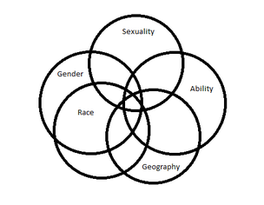
From michuhcan.org

Prompt #3-b:
- What intersecting aspects of your identities caused you to react to one of the Banksy works in the way that you imagined? Begin by diagramming aspects of your identities, like the diagram on the board. Add in whatever aspects you think matter that we haven’t discussed.

- Once you’ve completed your diagram, consider, in writing, how overlapping aspects of your identities have affected your reactions to one of the artworks. Focus on only a few aspects if that’s easier. But be sure to focus on the intersections of these aspects.

Sample images:
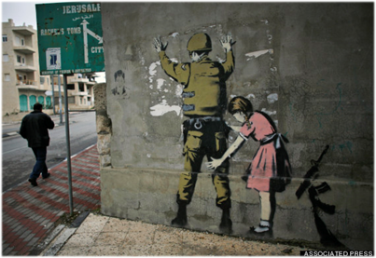
See Mosbergen, Dominique, for more on this image, and associated images.

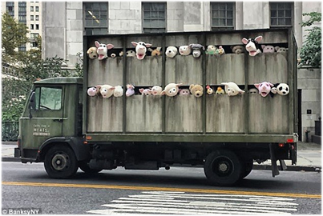
See Collman, Ashley, for more on this installation.

Works Referenced
Collman, Ashley. “Baa baa Banksy! Latest New York artwork is slaughterhouse truck filled with lively animal puppets which has won Peta's approval at least.” MailOnline.com. Associated Newspapers Ltd., 12 Oct 2013. Web. 2 Nov 2014.
Mosbergen, Dominique. “Controversial Banksy 'Christmas Card' Goes Viral Again.” Huffington Post. 25 Jan 2014. TheHuffingtonPost.com, Inc., 2 Nov 2014.
Exit Through the Gift Shop. Dir. Banksy. Paranoid Pictures, 2010.
michuhcan.org. Michigan Universal Health Care Access Network. Web. 3 Nov 2014. <http://michuhcan.files.wordpress.com/2013/03/intersectionality.png>
Vidal, Ava. “'Intersectional feminism'. What the hell is it? (And why you should care).” The Telegraph. Telegraph Media Group Limited, 15 Jan 2014. Web. 2 Nov 2014.

See the prompts below in the order that they were issued.
https://www.youtube.com/watch?v=DKYJVV7HuZw
https://www.youtube.com/watch?v=T_7ErkQFduQ
For examples by Banksy see http://banksy.co.uk/. For a variety of exmples see http://www.streetsy.com/, http://www.unurth.com/, or similiar websites.
The class before I facilitated Prompt #1, I assigned Banksy’s Exit Through the Gift Shop as “optional homework.” My aim was to provide a few willing students with background information on the artist himself, and street art in general.
An emphasis on rhetoric is crucial here. Without this emphasis, students may be drawn to write about the work on solely aesthetic terms.
An emphasis on you is crucial here, in order successfully introduce the levels of subjectivity needed to complete a Rogerian argument.
We explored the actual intersection of some of these identity attributes through the supplied Venn diagram. We filled in the categories already on the diagram, and added our own such as education, socioeconomic status, and age.

