Multimodal Transformation
This lesson plan is a full 70-min lesson centered around one activity, prompting discussion, and framing out of how understanding multimodality helps us encounter the limitations and affordances of the writing technologies and materials we deploy.

Introduction
Multimodality is one of the concepts that excites me most in writing studies. However, it’s also one that students and instructors seem to struggle talking about. This activity “Making Multimodality” was created as a response to my desire to see multimodality sponsored more explicitly and more fully in the context of WRTG 120, and to call attention to the course outcome of “Multimodal Transformation”. As such, this activity is heavily inflected with the work of Sirc (2002), New London Group (1996), Selfe (2009, 1999), Shipka (2011), Sousanis (2012), and Wysocki (2005) to name a few.

The activity, as I will outline below, involves students being given a mini-essay prompt and having to compose a response to that prompt in a given writing technology and then having to (re)mediate that essay in another, and then another, and so on. The purpose is to explicitly call attention to the act of transforming and to encounter the limitations and affordances of different composing materials and technologies.

Class Context
I used this activity to bridge between Project Two, Genres in the Wild and Project Three, Accessing Rhetoric, in which students would be transforming the graphic novel-style textbook, Understanding Rhetoric, into more accessible audio files. They had already read much of the textbook, but for this activity, emphasis was specifically placed on issues two (Strategic Reading) and seven (Going Public). Additionally, we had already had days on visual rhetoric, which seemed important for their being able to grasp another theoretically heavy concept, such as multimodality.

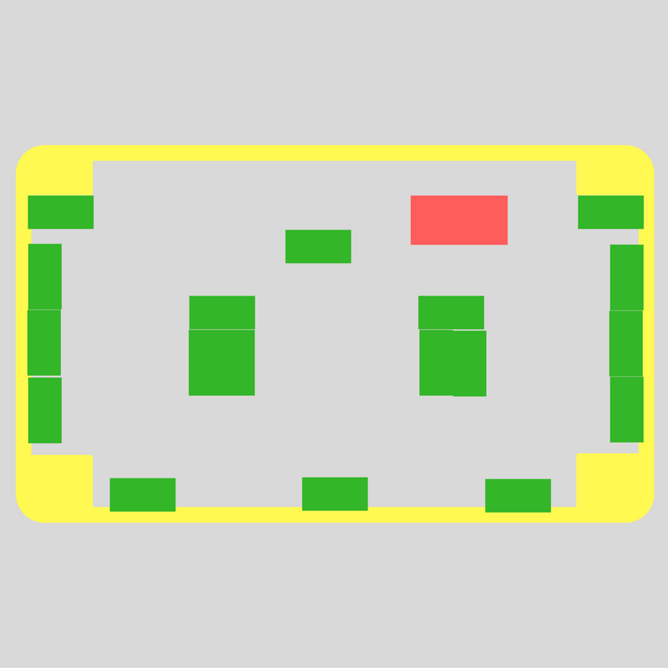
I start off each class session with a check in and housekeeping moment, before putting a series of discussion questions on the board that are generated from the two questions each student is required to post on Canvas each week; I, then, divide them into groups to tackle one of the questions. Then, we come back together and discuss. Following this, I have one or two activities as the focus of the day.

I arranged the desks to have three against each wall, two against the window, two clusters of three in the center and a front table. Chairs were placed against the wall or toward the windows. This was to serve a number of functions: one was the to break up students to ensure that each of the technologies would be used evenly, another was to enable movement as much as possible.

Activity: Making Multimodality
Mini-essay prompts (25, listed below) were cut up into strips of paper and placed into a bucket. Students pulled slips of paper from the bucket. Students were told:

- Each of you will have a mini-essay prompt slip.
- Find your way to a composing station with a writing technology.
- Compose your mini-essay that responds to your prompt. You will have approximately seven minutes to write.
- When I call time, move to another composing station. Carry your prompt with you.
- Now compose your mini-essay again, using the new technology.
- You will compose at 3-4 stations by the end of this activity.

At two minutes to the time, I gave a warning and invited students who needed to wash their hands to do so. Two minutes were given between each station to settle in. The total time came to roughly 36 minutes.

Students were able to compose with the following activity:

⧫ Pen/Copy Paper  ⧫ Collaging  ⧫ Legos  ⧫ Chalk/Chalkboard | ⧫ Num 2 Pencil /Kindergarten Paper  ⧫ Markers/Construction Paper  ⧫ Playdough  ⧫ Use your own tech | ⧫ Watercolors/Construction Paper  ⧫ Crayons/Construction Paper  ⧫ Sidewalk chalk/Construction Paper

Mini-Essay Prompts
Reflect on your first semester at Eastern. Compose a response that touches on the highlights or low spots in the semester | You’re going to be late for class! Compose something for your instructor to either let them know or apologize.
You want to break up with your significant other. Compose something to let them know. | Your best friend just went through a rough break up. Compose something to console them or respond to that situation.
Two celebrities have gotten into a twitter war and made #NoTeaNoShade a trending hashtag as more people get involved. How might you enter or respond to that conversation? | You have to take diligent notes for what’s going on in class around you. How might you do that with these writing technologies? Try it.
Summarize the last TV show or movie you watched using the technology in front of you. | Write out your to-do list for the next week using the materials in front of you.
The Student Government is having a fundraiser to support next year’s homecoming. Compose some form of advertising using the materials in front of you. | O no! Your project 2 is lost! Quickly rewrite your project as best you can from memory with the material or technology in front of you.
You’ve just been hired on board your favorite political candidate’s communication team to make their newest advertisement. How would you do that with the materials in front of you? | Gosh! The engineers still aren’t understanding why the railroad tracks at LaForge and Huron need addressing. Compose something to persuade the engineering team to work on this.
You’ve found a lost kitten in a tree. Poor thing. They don’t even have a collar! Compose a message to help you find their owner. | Write a convincing argument as to why everyone should watch your favorite show or movie.
Your favorite band is about to go on tour, but they need help marketing it. Compose something to market this new tour. | The university president needs to be aware of one thing (your choice). How will you address/explain this to him?
Your friend absolutely HAS to know what just happened at the Dining Commons. How might you let them know with the materials you have? | Good golly your instructor’s swell! How might you write them a thank you note?
Your roommate seems down-in-the-dumps lately. How might you compose something to cheer them up? | What do you mean you got a parking ticket? Try to appeal your fine using only the materials in front of you.
You hung your work up in the classroom only to have it taken down by administrators. How might you respond? | Your boss is observing you at work and everything is going wrong! Compose an apology or explanation to them.
Turn to any page in Understanding Rhetoric. Pick one frame. Try and recompose what you see using the material in front of you. | Watch the person next to you as they write. Why might they be making those choices? Interpret their work using the materials in front of you.
You want a new puppy. How might you convince a roommate? Guardian? Significant other? RA or housing coordinator?

Instructor and Observer
Copies of mini-essay prompts:

- Reflect on your first semester at Eastern. Compose a response that touches on the highlights or low spots in the semester
- You’re going to be late for class! Compose something for your instructor to either let them know or apologize.
- You want to break up with your significant other. Compose something to let them know.
- Your best friend just went through a rough break up. Compose something to console them or respond to that situation.
- Two celebrities have gotten into a twitter war and made #NoTeaNoShade a trending hashtag as more people get involved. How might you enter or respond to that conversation?
- You have to take diligent notes for what’s going on in class around you. How might you do that with these writing technologies? Try it.
- Summarize the last TV show or movie you watched using the technology in front of you.
- Write out your to-do list for the next week using the materials in front of you.
- The Student Government is having a fundraiser to support next year’s homecoming. Compose some form of advertising using the materials in front of you.
- O no! Your project 2 is lost! Quickly rewrite your project as best you can from memory with the material or technology in front of you.
- You’ve just been hired on board your favorite political candidate’s communication team to make their newest advertisement. How would you do that with the materials in front of you?
- Gosh! The engineers still aren’t understanding why the railroad tracks at LaForge and Huron need addressing. Compose something to persuade the engineering team to work on this.
- You’ve found a lost kitten in a tree. Poor thing. They don’t even have a collar! Compose a message to help you find their owner.
- Write a convincing argument as to why everyone should watch your favorite show or movie.
- Your favorite band is about to go on tour, but they need help marketing it. Compose something to market this new tour.
- The university president needs to be aware of one thing (your choice). How will you address/explain this to him?
- Your friend absolutely HAS to know what just happened at the Dining Commons. How might you let them know with the materials you have?
- Good golly your instructor’s swell! How might you write them a thank you note?
- Your roommate seems down-in-the-dumps lately. How might you compose something to cheer them up?
- What do you mean you got a parking ticket? Try to appeal your fine using only the materials in front of you.
- You hung your work up in the classroom only to have it taken down by administrators. How might you respond?
- Your boss is observing you at work and everything is going wrong! Compose an apology or explanation to them.
- Turn to any page in Understanding Rhetoric. Pick one frame. Try and recompose what you see using the material in front of you.
- Watch the person next to you as they write. Why might they be making those choices? Interpret their work using the materials in front of you.
- You want a new puppy. How might you convince a roommate? Guardian? Significant other? RA or housing coordinator?

Sources
Sirc, Geoffrey. (2002). English composition as a happening. Logan, UT: Utah State University Press.
New London Group. (1996). A pedagogy of multiliteracies: Designing social futures. Harvard Educational Review 66, 60-92.
Selfe, Cynthia. (2009). The movement of air, the breath of meaning: Aurality and multimodal composing. College Composition and Communication 60, 616-63
—. (1999). Technology and literacy: A story about the perils of not paying attention. College Composition and Communication 50.3, 411-36.
Shipka, Jody. (2011). Toward a composition made whole. Pittsburgh, PA: University of Pittsburgh Press.
Sousanis, Nick. (2012). Unflattening. Cambridge, MA: Harvard University Press.
Wysocki, Anne F. (2005). awaywithwords: On the possibilities in unavailable designs. Computers and Composition 22, 55-62.

